**Web Designing Assignment**

**Module (CSS and CSS 3) -2**

**Que. 1) What are the benefits of using CSS?**

**Ans:Benefits of using CSS**

1)CSS(Cascading style sheet) is used for apply the style to web pages

2)By using css you simply got to specify a repeated style for HTML files & use it multiple times

3)Using css you will control color of text,design of fonts, spacing in paragraphs & create attractive layouts

4)CSS enables to use less code means faster page speed

---------------------------------------------------------------------------------------------------

**Que. 2) What are the disadvantages of CSS?**

**Ans:Disadvantage of CSS**

1) There might be cross-browser issues while using CSS

2) The programming langauge is complicated for non-developers & beginners

3) Creates confusion due to its many levels

4) CSS works different in different browser

---------------------------------------------------------------------------------------------------

**Que. 3) What is the difference between CSS2 and CSS3?**

**Ans:**

|  |  |
| --- | --- |
| **CSS2** | **CSS3** |
| Specified in single documents | Divided into individual documents |
| CSS2 does not support border-box property | CSS3 supports the border-box property |
| Using CSS2 applied rounded border css styles were complex | Using CSS3 automaticaly assigning rounded border |
| Simple selectors are available | A sequence of selectors are available |
| CSS2 only used web-safe fonts | CSS3 used special font like google fonts & typecast |

---------------------------------------------------------------------------------------------------

**Que. 4) Name a few CSS style components?**

**Ans:**

**1) Selector:** class name, id name or element name that is target

**2) Property:** Properties like attribute you want to style for example border, color, background, backgrond-color, font-size position etc.

**3) Value:** value that will be assigned to properties

**Example:CSS style**

P{

color:red;

border:2px solid black;

text-align:center;

**Style components**

**P**: where p is the selector

**Color, border, text-align**: properties to style the selector

**Red, 2px solid black, text-align**: value assign to properties

---------------------------------------------------------------------------------------------------

**Que. 5) What do you understand by CSS opacity?**

**Ans:** Opacity sets the opacity level of an element & describe the transperancy.

**Example Code:**

<!DOCTYPE html>

<html lang="en">

<head>

<meta charset="UTF-8">

<meta http-equiv="X-UA-Compatible" content="IE=edge">

<meta name="viewport" content="width=device-width, initial-scale=1.0">

<title>Document</title>

<style>

*{

box-sizing: border-box;

margin: 0;

padding: 0;

}

div{

position: relative;

top: 50px;

left: 50px;

height: 100px;

width: 200px;

background-color: red;

opacity: .4;

}

</style>

</head>

<body>

<div>lorem</div>

</body>

</html>

**Output:**

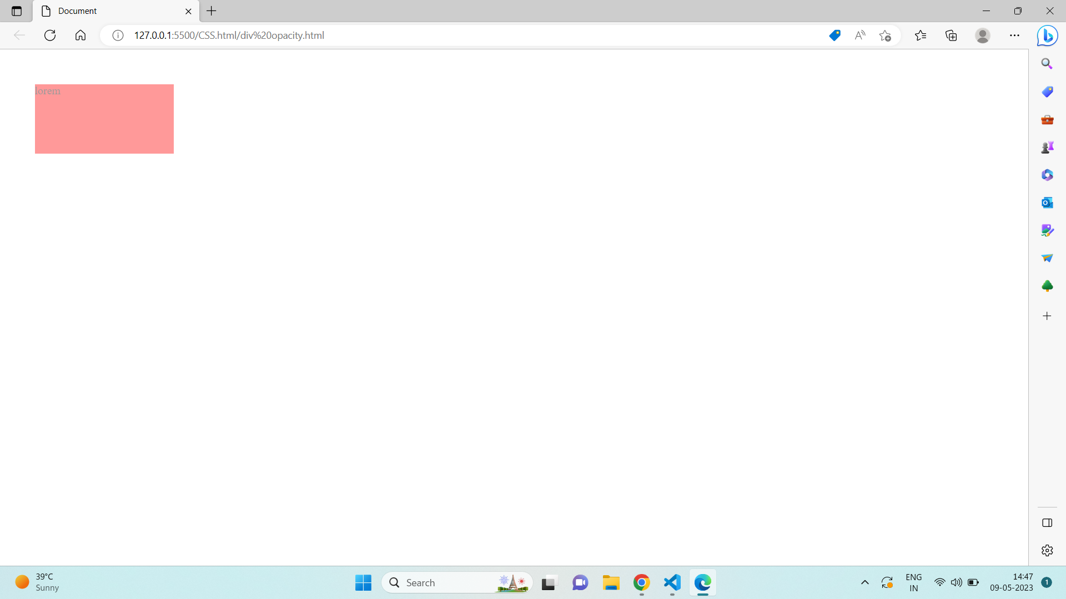

---------------------------------------------------------------------------------------------------

**Que. 6) How can the background color of an element be changed?**

**Ans**: Using background-color:red property we can change the color of element.

Example Code:

<!DOCTYPE html>

<html lang="en">

<head>

<meta charset="UTF-8">

<meta http-equiv="X-UA-Compatible" content="IE=edge">

<meta name="viewport" content="width=device-width, initial-scale=1.0">

<title>Document</title>

<style>

body {

background-color: coral;

}

</style>

</head>

<body>

<h1>Lorem</h1>

<p>Lorem ipsum, dolor sit amet consectetur adipisicing elit. Assumenda velit sint ab ullam? Quam quibusdam doloribus</p>

</body>

</html>

</body>

</html>

**Output:**

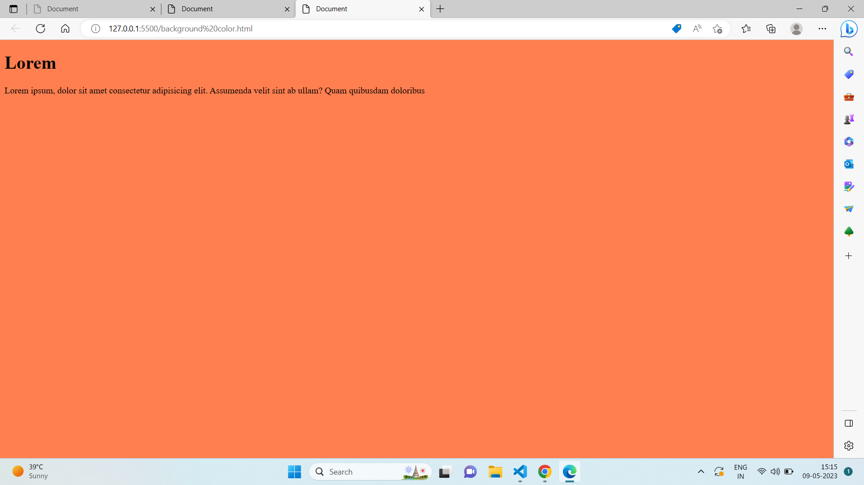

---------------------------------------------------------------------------------------------------

**Que. 7) How can image repetition of the backup be controlled?**

**Ans:** In CSS background repeat property is work like a backround image repeat in X-direction or Y-direction also it’s decided whether the backround image is repeated or not.

**Example:**

* background-repeat:repeat
* background-repeat:no-repeat
* background-repeat:repeat-x
* background-repeat:repeat-y
* background-repeat:initial
* background-repeat:inherit

**Example Code:**

<!DOCTYPE html>

<html>

<head>

<style>

body {

margin-top: 40px;

background-image: url("discovery-454.jpg");

background-repeat: repeat-x;

background-size: 200px 200px;

}

h1 {

text-align: center;

}

</style>

</head>

<body>

<h1>Lorem</h1>

</body>

</html>

**Output:**

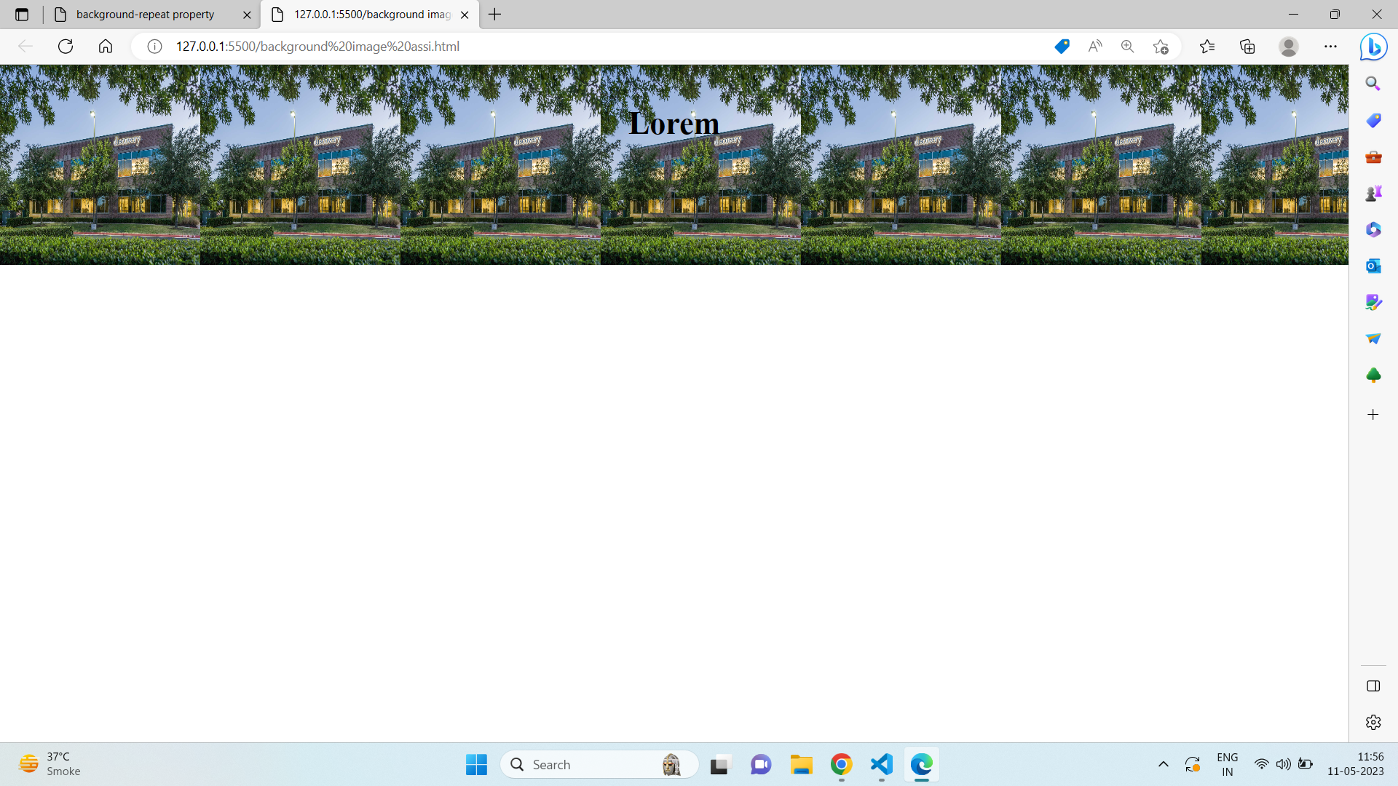

---------------------------------------------------------------------------------------------------

**Que. 8) What is the use of the background-position property?**

**Ans:**Backround-position sets the starting position of image

Example Code:

<!DOCTYPE html>

<html>

<head>

<style>

body {

background-image: url("discovery-454.jpg");

background-repeat: no-repeat;

background-attachment: fixed;

background-size: 500px 500px;

background-position: right top;

}

</style>

</head>

<body>

</body>

</html>

**Output:**

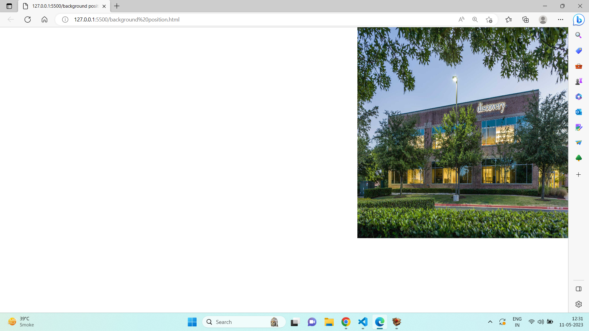

---------------------------------------------------------------------------------------------------

**Que. 9) Which property controls the image scroll in the background?**

**Ans:**Backround-attachment property is used to scroll or fixed the image.

Example code:

<!DOCTYPE html>

<html>

<head>

<style>

#one {

background-image:url("xCustomer-lifecycles_03-800x480.png.pagespeed.ic.CYgJqwksgU.png");

background-position: center;

background-repeat: no-repeat;

background-attachment: scroll;

}

</style>

</head>

<body>

<div id="one">

<p>

Lorem ipsum dolor sit amet consectetur adipisicing elit. Nobis,<br> <br> <br> suscipit placeat debitis nemo laboriosam <br> <br> <br>hic perferendis facere esse sed voluptatibus facilis, ad officiis?<br> <br> <br> Reiciendis optio blanditiis, at doloremque maxime necessitatibus. Et quidem fuga aperiam recusandae. Sapiente iure qui <br> <br> <br>inventore quas incidunt quod optio. Rem nobis ipsa at quos quis distinctio harum, <br> <br> <br>culpa et! Mollitia, rerum delectus impedit maiores laudantium iusto.<br> <br> <br>A architecto cupiditate libero perferendis illo <br> <br> <br>tempore dolorum doloremque fugit quasi magnam, sunt,<br> <br> <br> harum modi similique nesciunt hic voluptatibus odio quis voluptas delectus, vitae tenetur omnis corrupti corporis voluptates! Saepe?Porro animi voluptate praesentium quo. Laboriosam <Br> <br> quis harum magni non possimus <br> <br> <br> est eum qui, repellat excepturi, ipsa eos <br> <br> <br>exercitationem dolorum blanditiis quia deserunt aliquid sint illo quaerat modi distinctio! Dolorem?Animi repellat dolores earum quia obcaecati velit<br> <br> <br> odit amet beatae. Provident modi ad quibusdam quia vel <br> <br> <br>officiis tenetur laudantium! Voluptatibus odio quae reprehenderit illo,<br> <br> <br> unde labore consectetur minus blanditiis asperiores.

</p>

</div>

</body>

</html>

**Output:**

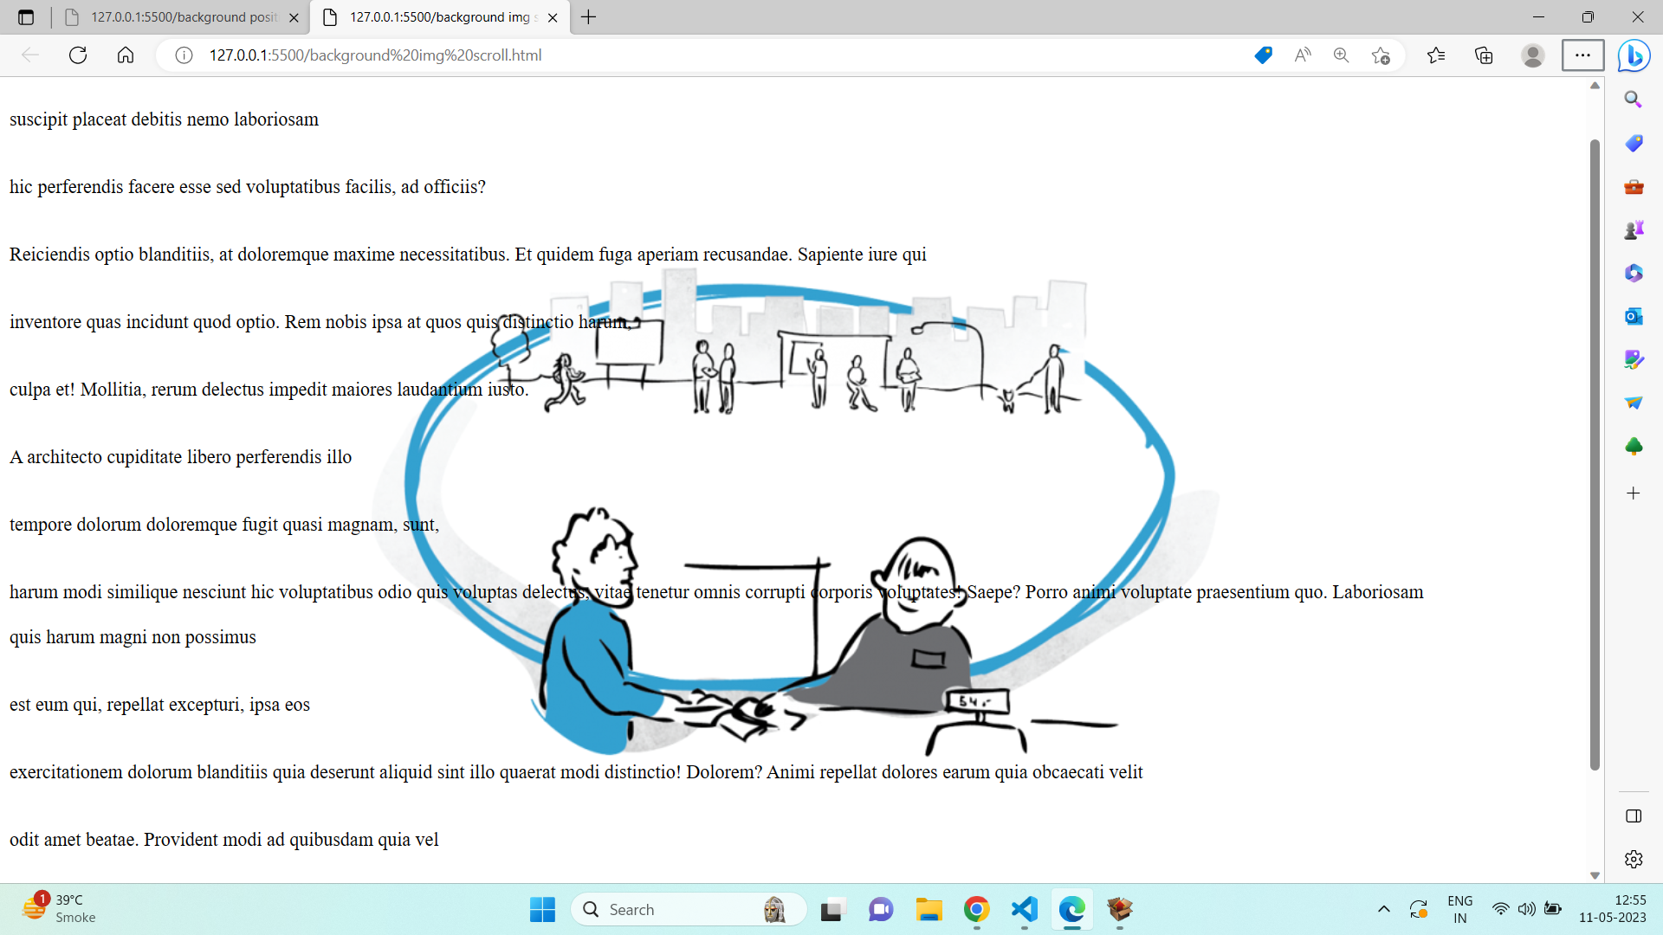

---------------------------------------------------------------------------------------------------

**Que. 10) Why should background and color be used as separate properties?**

**Ans:Background:** is used to set the color,image,size or fixed,local,scroll in the background

**Color:** is used to set the text-color

**Example Code:**

<!DOCTYPE html>

<html lang="en">

<head>

<meta charset="UTF-8">

<meta http-equiv="X-UA-Compatible" content="IE=edge">

<meta name="viewport" content="width=device-width, initial-scale=1.0">

<title>Document</title>

<style>

div {

height: 500px;

width: 500px;

background: fixed;

background-color: teal;

color: white;

}

</style>

</head>

<body>

<div>

Lorem ipsum dolor sit amet consectetur adipisicing elit. Asperiores iure fugit sapiente

sequi architecto, fugiat, impedit natus facere quo consectetur cumque magni nemo

modi omnis beatae illum sit quisquam recusandae.

</div>

</body>

</html>

**Output:**

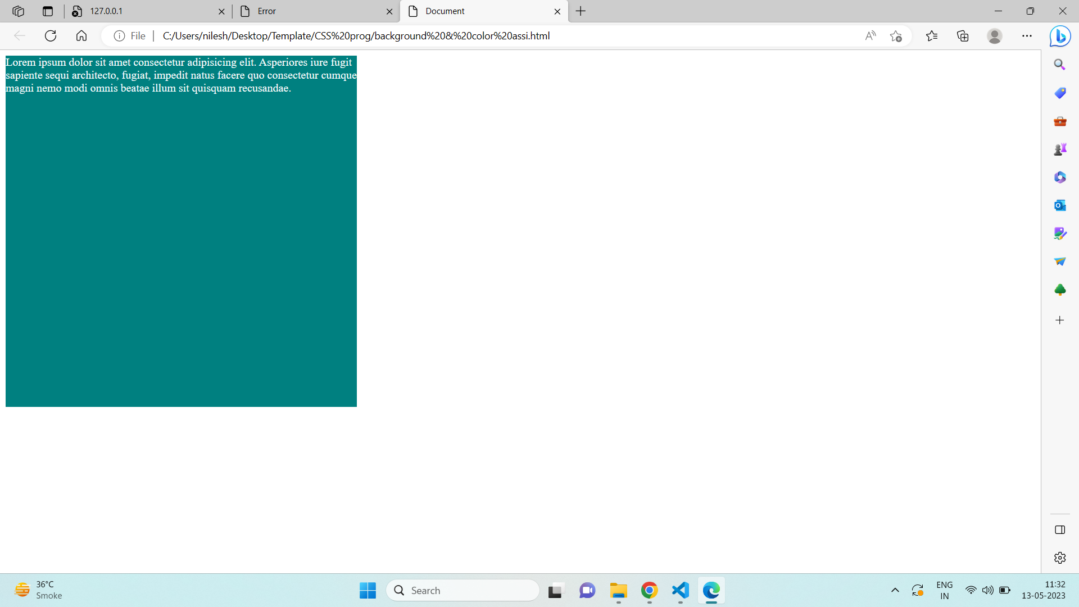

---------------------------------------------------------------------------------------------------

**Que. 11) How to center block elements using CSS1?**

**Ans:** To center the block level element using CSS both margin-left & margin-right are auto they will be set to equal values.

**Example Code:**

<!DOCTYPE html>

<html lang="en">

<head>

<meta charset="UTF-8">

<meta http-equiv="X-UA-Compatible" content="IE=edge">

<meta name="viewport" content="width=device-width, initial-scale=1.0">

<title>Document</title>

<style>

div {

border: 2px solid black;

height: 250px;

margin-left: auto;

margin-right: auto;

width: 250px;

}

</style>

</head>

<body>

<div></div>

</body>

</html>

**Output:**

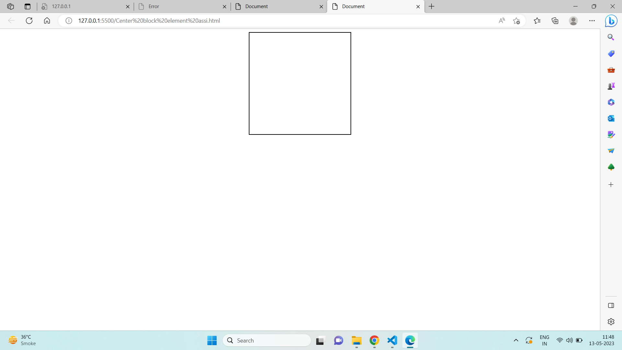

---------------------------------------------------------------------------------------------------

**Que.12) How to maintain the CSS specifications?**

**Ans:** The Specification defines how CSS properties should be implemented by browser vendors along with detailed algorithms, code samples and tabular information.

The Specification also include:

* The syntax and data types of the language
* Detailed explanation on CSS Selectors
* How you can assign values to properties
* The Cascade (the "C" in CSS)
* How inheritance works
* The Box Model

---------------------------------------------------------------------------------------------------

**Que.13) What are the ways to integrate CSS as a web page?**

**Ans:**Three ways to integrate CSS as a web page

* External CSS:using external style sheet change the style of website
* Internal CSS:used if one single page HTML has a unique style
* Inline CSS:used to unique style to single element

**Example Code:External CSS**

<!DOCTYPE html>

<html lang="en">

<head>

<meta charset="UTF-8">

<meta http-equiv="X-UA-Compatible" content="IE=edge">

<meta name="viewport" content="width=device-width, initial-scale=1.0">

<title>Document</title>

<link rel="stylesheet" href="style.css">

</head>

<body>

<h1>Lorem</h1>

<p>Lorem ipsum dolor sit amet consectetur adipisicing elit.</p>

</body>

</html>

**External CSS Code:**

body {

background-color: lightblue;

}

h1 {

color: navy;

margin-left: 50px;

}

**Output:**

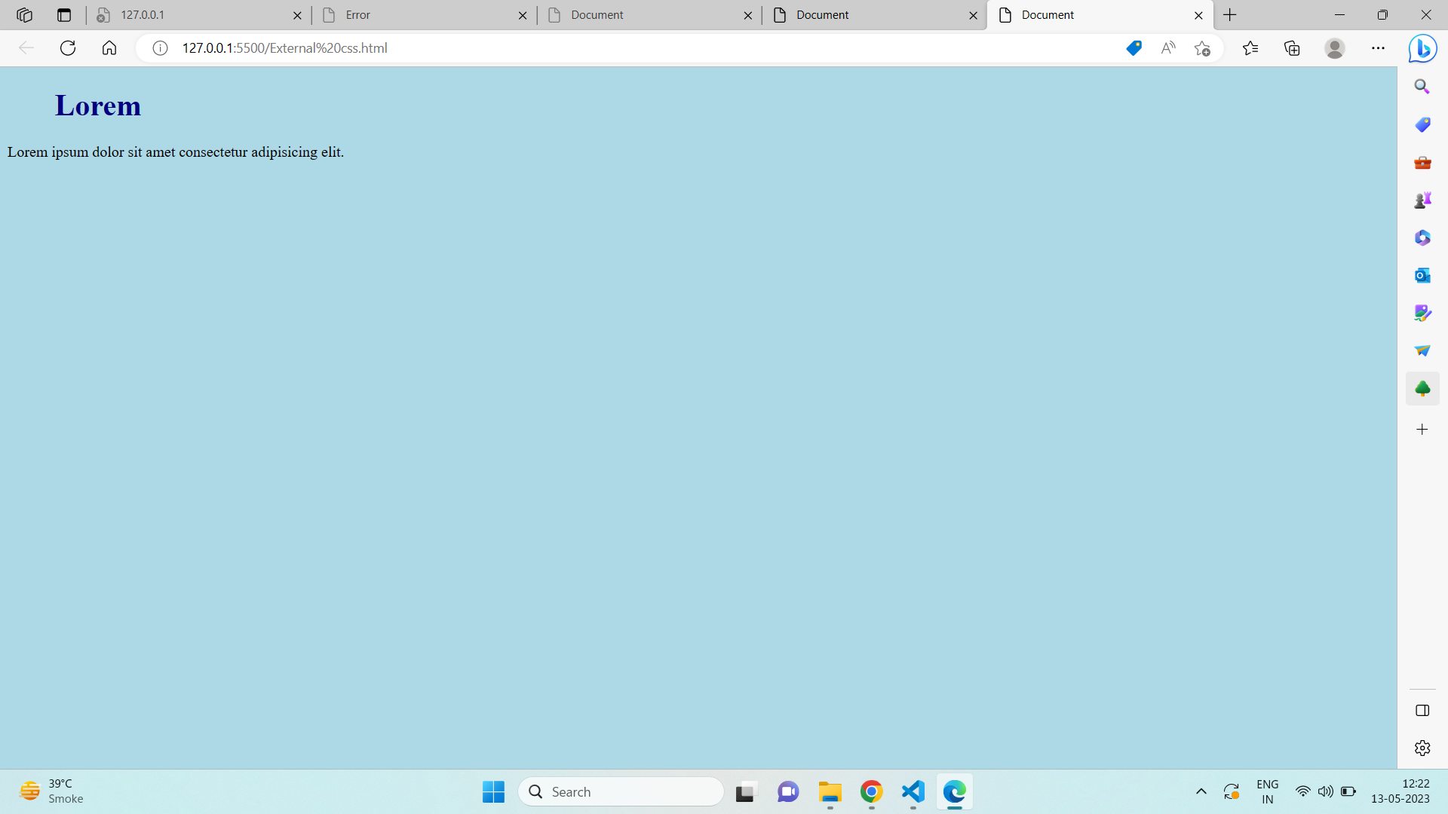

**Internal CSS**

**Example Code:**

<!DOCTYPE html>

<html lang="en">

<head>

<meta charset="UTF-8">

<meta http-equiv="X-UA-Compatible" content="IE=edge">

<meta name="viewport" content="width=device-width, initial-scale=1.0">

<title>Document</title>

<style>

body {

background-color: blueviolet;

}

h1 {

color: white;

margin-left: 50px;

}

</style>

</head>

<body>

<h1>Lorem</h1>

<p>Lorem ipsum dolor sit amet consectetur adipisicing elit.</p>

</body>

</html>

**Output:**

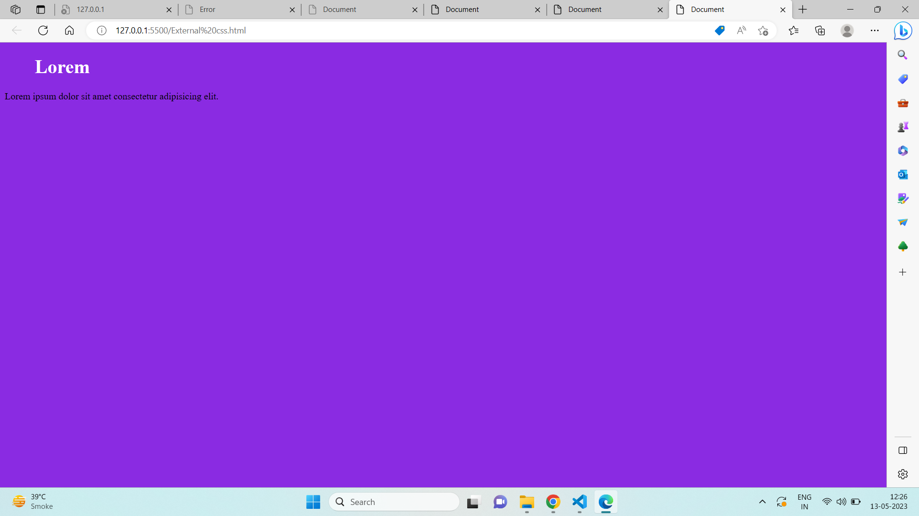

**Inline CSS**

**Example Code:**

<!DOCTYPE html>

<html lang="en">

<head>

<meta charset="UTF-8">

<meta http-equiv="X-UA-Compatible" content="IE=edge">

<meta name="viewport" content="width=device-width, initial-scale=1.0">

<title>Document</title>

<body>

<h1 style="color:blue;text-align:center;">lorem</h1>

<p style="color:red;">Lorem ipsum dolor sit amet consectetur adipisicing elit.</p>

</body>

</html>

**Output:**

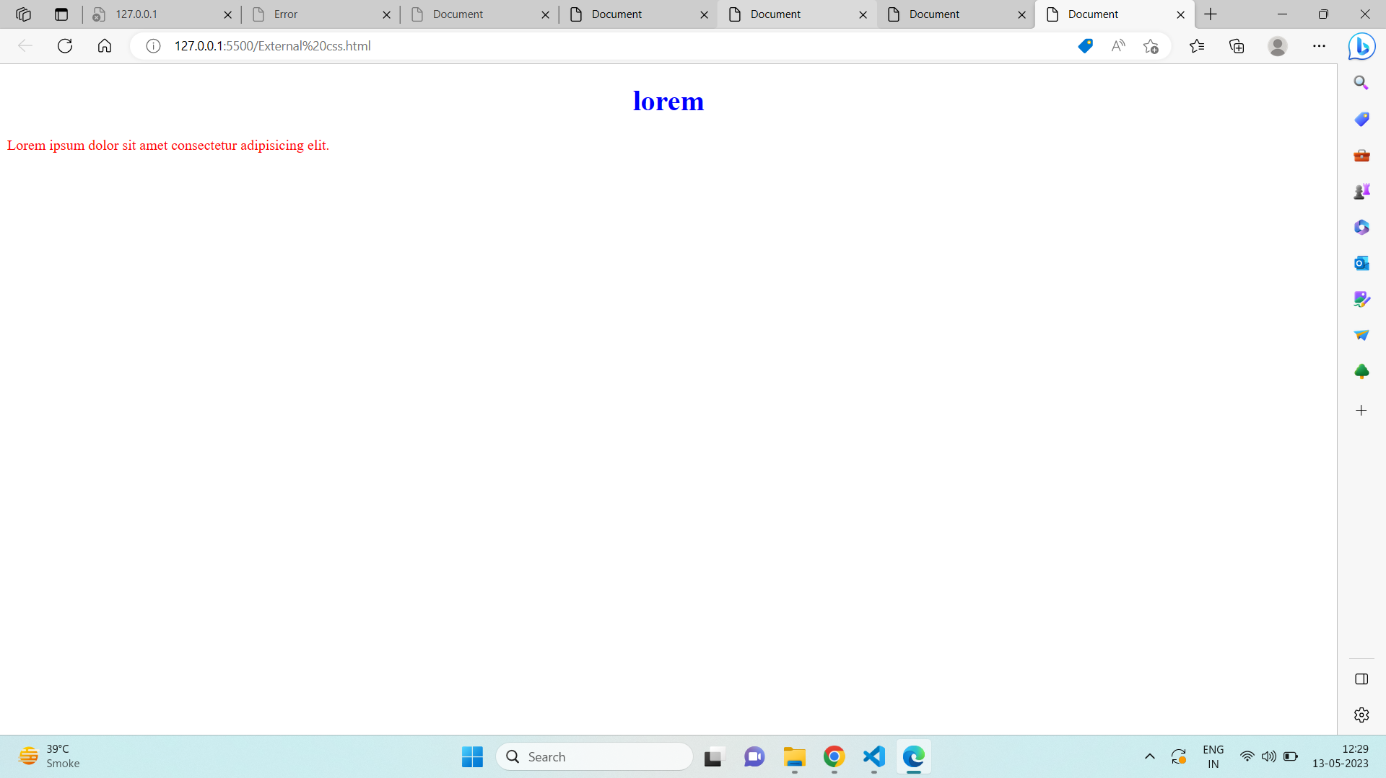

---------------------------------------------------------------------------------------------------

**Que. 14) What is embedded style sheets?**

**Ans:** It allows you to define styles for a particular HTML document as a whole in one place. This is done by embedding the **<style></style>** tags containing the CSS properties in the head of your document.

**Example Code:**

<!DOCTYPE html>

<html>

<head>

<!-- Embedded stylesheet -->

<style>

h2 {

font-size: xx-large;

color: blue;

text-align: center;

}

p {

text-align: center;

background-color: green;

}

</style>

</head>

<body>

<h2>Lorem</h2>

<p>Lorem ipsum dolor sit amet consectetur adipisicing elit</p>

<p>Lorem ipsum dolor sit amet consectetur adipisicing elit</p>

<p>Lorem ipsum dolor sit amet consectetur adipisicing elit</p>

</body>

</html>

**Output:**

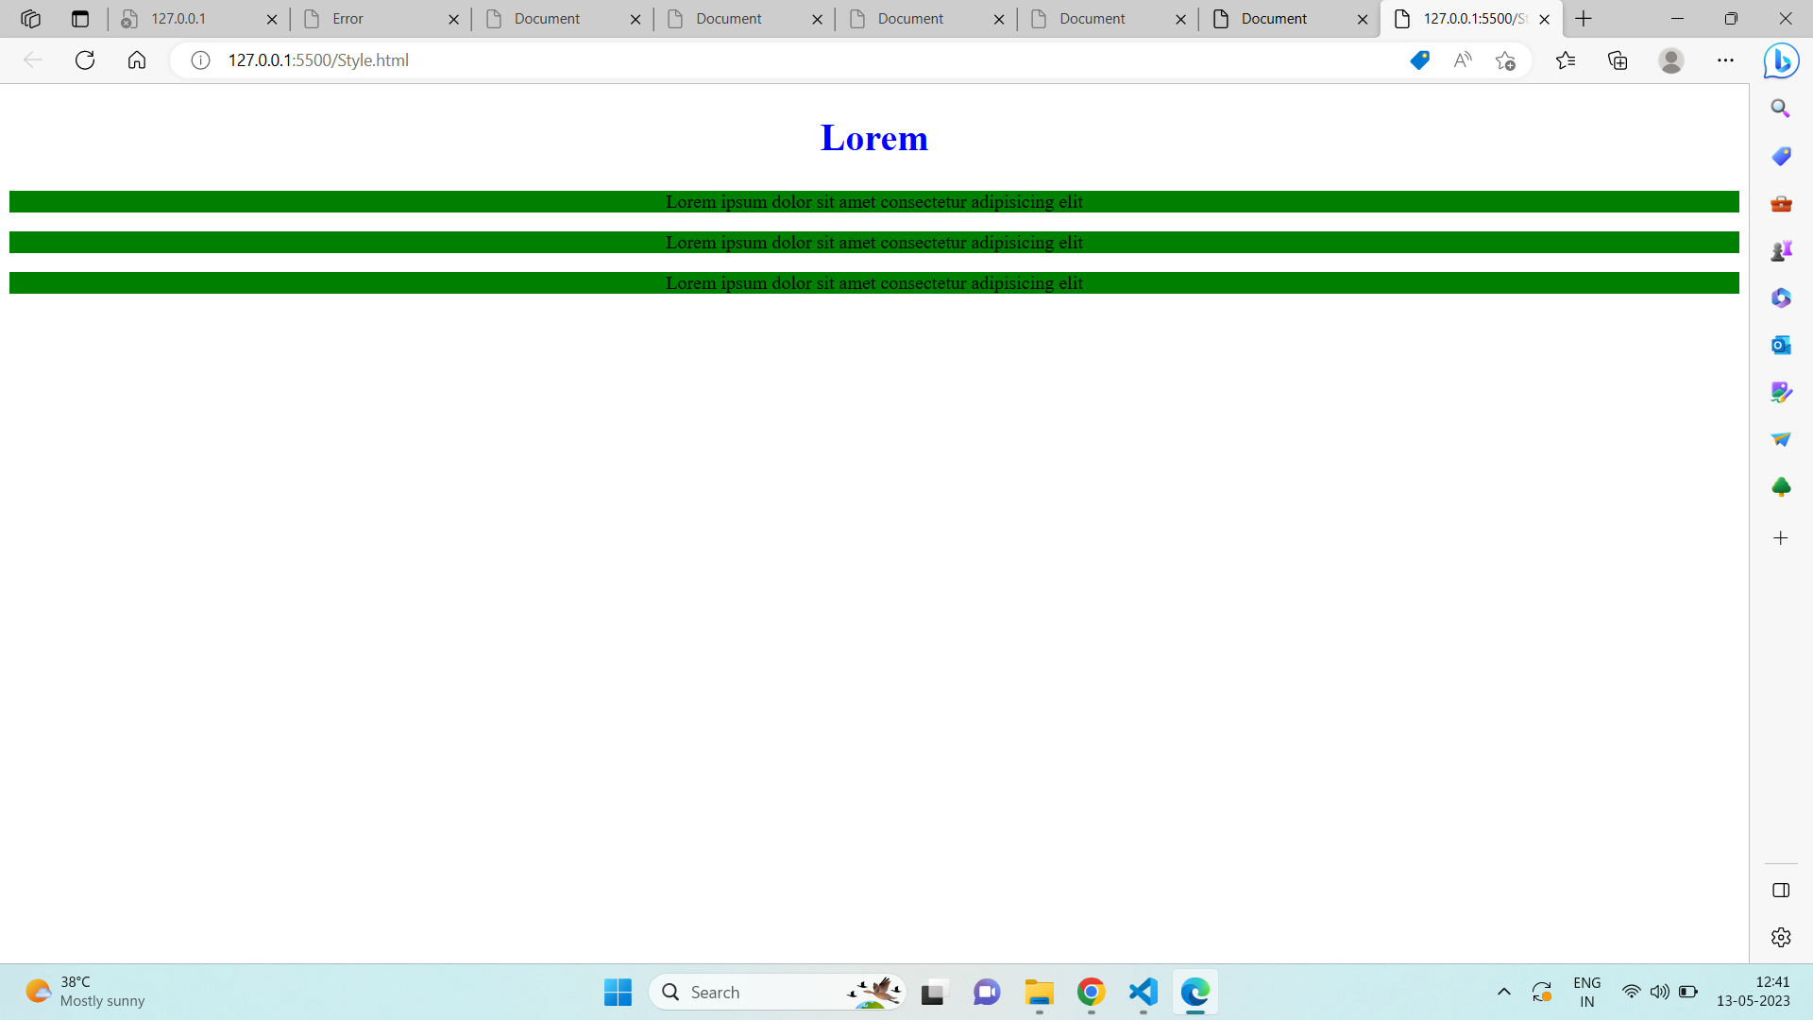

--------------------------------------------------------------------------------------------------

**Que. 15) What are the external style sheets?**

**Ans:** An external file is a separate file linked to the HTML web page it will define by .CSS filename extention.all the style that need to design website can declared in the external style sheets.

**Example Code:**

<!DOCTYPE html>

<html lang="en">

<head>

<meta charset="UTF-8">

<meta http-equiv="X-UA-Compatible" content="IE=edge">

<meta name="viewport" content="width=device-width, initial-scale=1.0">

<title>Document</title>

<link rel="stylesheet" href="style.css">

</head>

<body>

<h1>Lorem</h1>

<p>Lorem ipsum dolor sit amet consectetur adipisicing elit.</p>

</body>

</html>

**External CSS Code:**

body {

background-color: lightblue;

}

h1 {

color: navy;

margin-left: 50px;

}

**Output:**



--------------------------------------------------------------------------------------------------

**Que. 16) What are the advantages and disadvantages of using external style sheets?**

**Ans:Advantage of external CSS:**

1) Using them, the styles of multiple documents can be controlled from one file.  
2) Classes can be created for use on multiple HTML element types in many documents.  
3)In complex situations, selector and grouping methods can be used to apply styles.

**Disadvantages of external CSS:**

1) In order to import style information for each document, an extra download is needed.  
2) Until the external style sheet is loaded, it may not be possible to render the document.  
3) For small number of style definitions, it is not viable.

--------------------------------------------------------------------------------------------------

**Que. 17) What is the meaning of the CSS selector?**

**Ans:**Below are the types of CSS selector

1. CSS element selector: The element selector selects HTML elements based on the element name.
2. CSS ID selector: The id of an element is unique within a page, so the id selector is used to select one unique element write a hash (#) character, followed by the id of the element
3. CSS Class selector: The class selector selects HTML elements with a specific class attribute.To select elements with a specific class, write a period (.) character, followed by the class name.
4. CSS universal selector: The universal selector (*) selects all HTML elements on the page.
5. CSS grouping selector: The grouping selector selects all the HTML elements with the same style definitions.

---------------------------------------------------------------------------------------------------

**Que. 18) What are the media types allowed by CSS?**

**Ans:** We can add the breakpoint to see the screen width along with the width and height of the viewport for the different devices.

A breakpoint is a point or key that determines when to change the layout by reshaping & adding new rules inside the media queries. There are some common breakpoints, not a standard resolution, that can be used for the different widths & heights of devices:

* For Mobile devices: 320px-480px
* For Tablets or iPad: 480px - 768px
* For Laptop or small-size screen: 768px -1024px
* For Desktop or large-size screen: 1024px -1200px
* For Extra-large size device: 1200px and more

--------------------------------------------------------------------------------------------------

**Que. 19) What is the rule set?**

**Ans:** In general, a CSS rule is composed of a selector, a declaration block, properties, and values.

**Example:**

Selector->h1{

property->color:red <-value

Declaration box

}

-The selector indicates which type of content is to be styled by the CSS rule.In the CSS example, the selector is the <h1> HTML element, which is a tag selector

- The declaration block is the part of the CSS rule that declares a style rule for the selector. In the CSS example, the declaration block is color:blue;.

-The property refers to the property of the HTML content that the CSS rule will modify, such as font-size or color. In the CSS example, the property is color.

-The value refers to the specific value assigned to the property, such as 16px or red. In the example CSS rule, the value is red.  
--------------------------------------------------------------------------------------------------

**Que.20) Create image gallery using display grid with responsive?**

**Ans:** <!DOCTYPE html>

<html lang="en">

<head>

<meta charset="UTF-8">

<meta http-equiv="X-UA-Compatible" content="IE=edge">

<meta name="viewport" content="width=device-width, initial-scale=1.0">

<title>Document</title>

<style>

div {

display: grid;

grid-template-columns: repeat(12);

}

.one {

border: 10px black solid;

padding: 20px;

}

#line1 {

grid-column: 1/7;

height: 200px;

background-image: url(image\ chiken.html.png);

background-repeat: no-repeat;

background-size: cover;

}

#line2 {

grid-column: 7/12;

background-image: url(image\ chiken.html.png);

background-repeat: no-repeat;

background-size: cover;

}

#line3 {

grid-column: 1/4;

height: 200px;

background-image: url(image\ chiken.html.png);

background-repeat: no-repeat;

background-size: cover;

}

#line4 {

grid-column: 4/8;

background-image: url(image\ chiken.html.png);

background-repeat: no-repeat;

background-size: cover;

}

#line5 {

grid-column: 8/12;

background-image: url(image\ chiken.html.png);

background-repeat: no-repeat;

background-size: cover;

}

#line6 {

grid-column: 1/6;

height: 200px;

background-image: url(image\ chiken.html.png);

background-repeat: no-repeat;

background-size: cover;

}

#line7 {

grid-column: 6/12;

background-image: url(image\ chiken.html.png);

background-repeat: no-repeat;

background-size: cover;

}

#line8 {

grid-column: 1/4;

height: 100px;

background-image: url(image\ chiken.html.png);

background-repeat: no-repeat;

background-size: cover;

}

#line9 {

grid-column: 4/8;

background-image: url(image\ chiken.html.png);

background-repeat: no-repeat;

background-size: cover;

}

#line10 {

grid-column: 8/12;

background-image: url(image\ chiken.html.png);

background-repeat: no-repeat;

background-size: cover;

}

</style>

</head>

<body>

<div>

<div class="one" id="line1"></div>

<div class="one" id="line2"></div>

<div class="one" id="line3"></div>

<div class="one" id="line4"></div>

<div class="one" id="line5"></div>

<div class="one" id="line6"></div>.

<div class="one" id="line7"></div>

<div class="one" id="line8"></div>

<div class="one" id="line9"></div>

<div class="one" id="line10"></div>

</div>

</body>

</html>

**Output:**

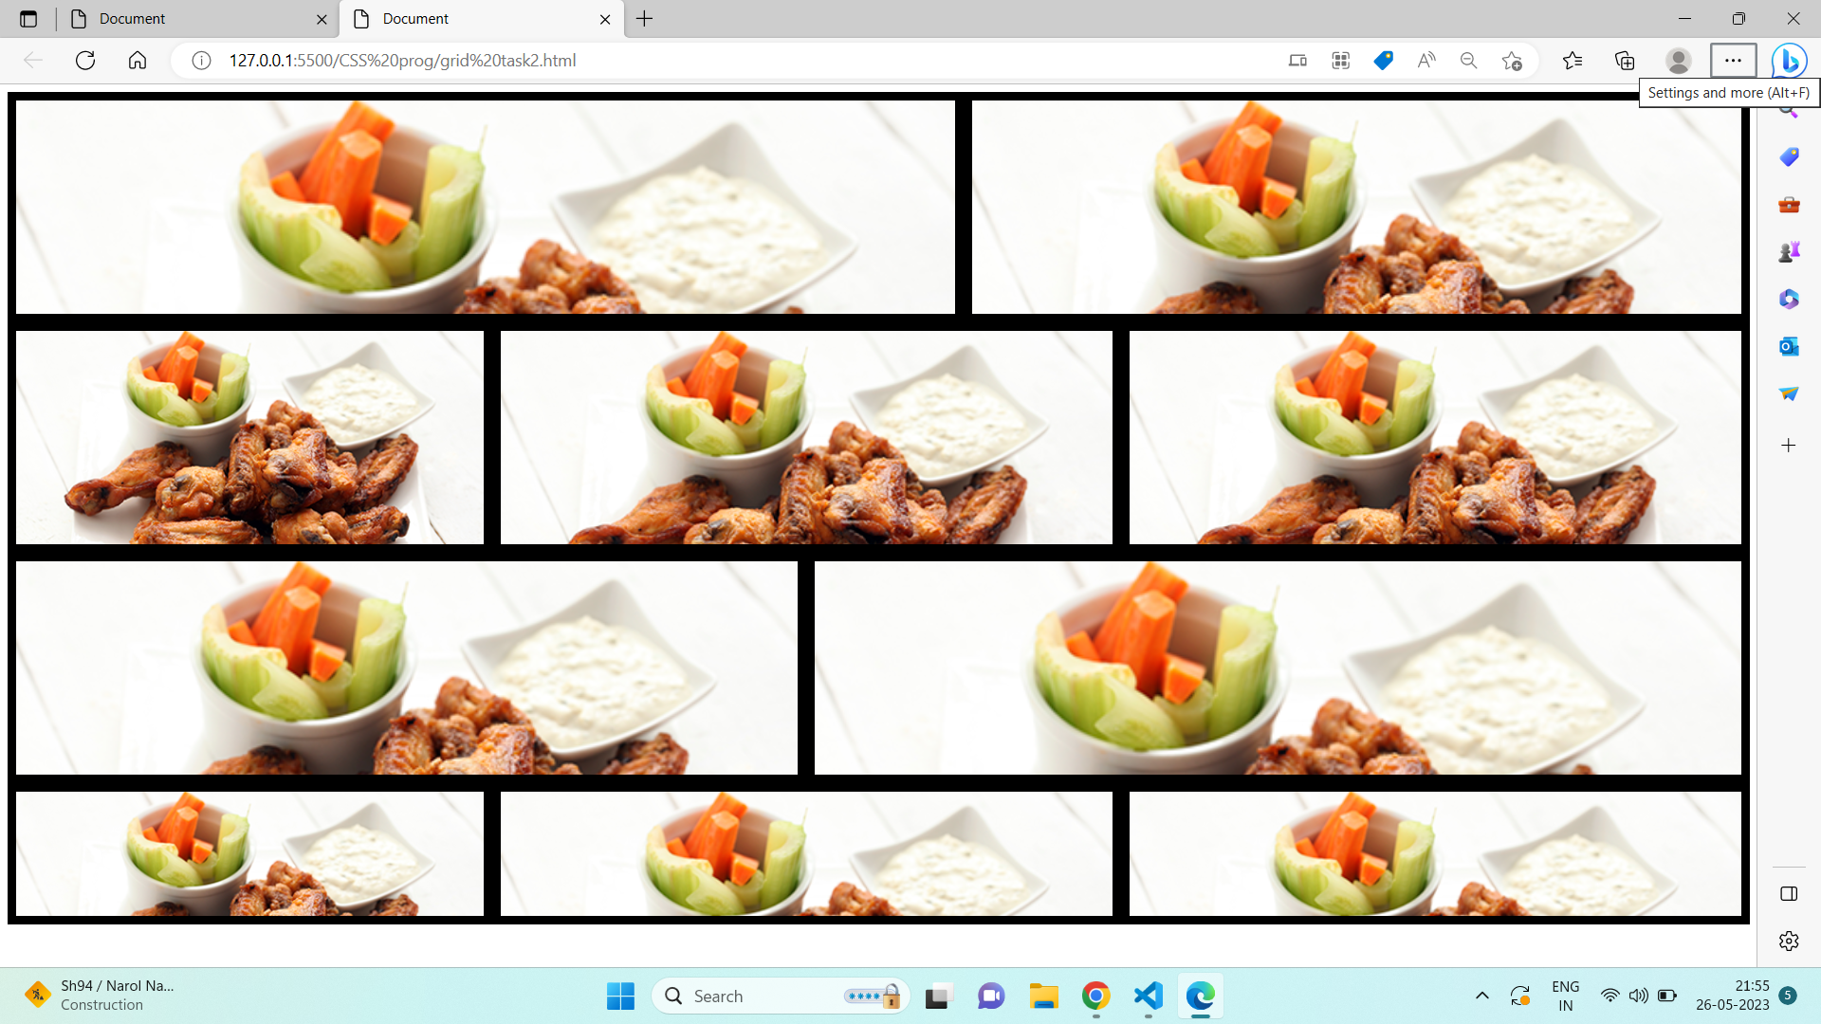

--------------------------------------------------------------------------------------------------

**Que.21) Multiple background one side bg-color other side contain image as bg?**

**Ans:** <!DOCTYPE html>

<html lang="en">

<head>

<meta charset="UTF-8">

<meta http-equiv="X-UA-Compatible" content="IE=edge">

<meta name="viewport" content="width=device-width, initial-scale=1.0">

<title>Document</title>

<style>

* {

margin: 0;

padding: 0;

box-sizing: border-box;

}

.container {

display: flex;

width: 1041px;

height: 768px;

background-color: #202020;

}

img {

position: relative;

left: 50%;

}

h3 {

position: relative;

top: 70px;

left: 700px;

font-size: 36px;

letter-spacing: 4px;

color: #f4f5f9;

font-weight: 700;

font-family: "Source Sans Pro";

}

h5 {

position: relative;

top: 130px;

left: 60%;

width: 587px;

height: 74px;

font-size: 18px;

line-height: 29px;

color: #e74c3c;

font-weight: 600;

font-family: "Open Sans";

text-align: right;

}

p {

position: relative;

top: 100px;

left: 400px;

color: white;

}

</style>

</body>

<div class="container">

<div id="one">

<h3>OUR SERVICES</h3>

<h5>Web Design</h5>

<p>Lorem ipsum dolor, sit amet consectetur adipisicing elit. Officia nesciunt quos, error commodi eius, ea

voluptas facilis velit laboriosam dignissimos sit veniam distinctio debitis nulla recusandae dicta

molestias. Expedita, earum!</p>

<h5>Print Design</h5>

<p>Lorem ipsum dolor sit, amet consectetur adipisicing elit. Quibusdam minus explicabo dolorum odio sapiente

libero incidunt unde temporibus aspernatur earum praesentium, assumenda maxime magni odit nemo facilis.

Qui, dolorum sed?</p>

<h5>Photography</h5>

<p>Lorem ipsum dolor sit amet consectetur, adipisicing elit. Sit consequuntur saepe, nam aliquam quidem

aspernatur modi autem facere dolor tempora, ipsa fugit in ipsum libero delectus molestias labore

expedita incidunt.</p>

</div>

<div id="two">

<img src="Put Your Image.svg" alt="">

</div>

</div>

</html>

**Output:**

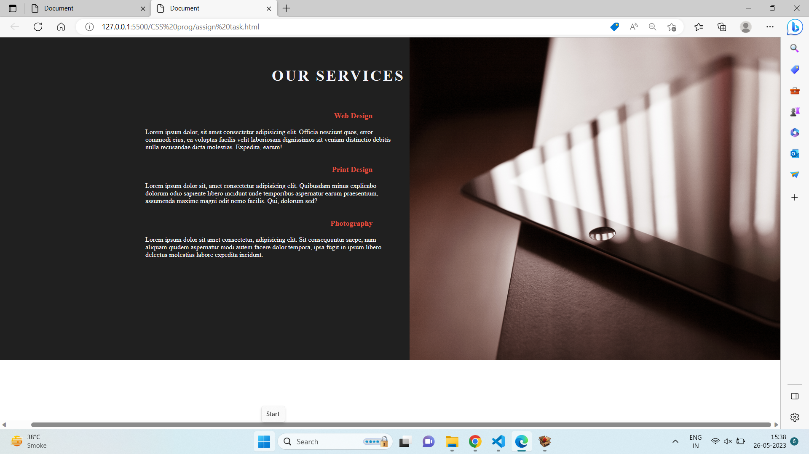

---------------------------------------------------------------------------------------------------

**Que. 21) Create below example using css waves generator?**

**Ans:**

<!DOCTYPE html>

<html lang="en">

<head>

<meta charset="UTF-8">

<meta http-equiv="X-UA-Compatible" content="IE=edge">

<meta name="viewport" content="width=device-width, initial-scale=1.0">

<title>Document</title>

<style>

* {

margin: 0;

padding: 0;

box-sizing: border-box;

}

body {

background-image: url(assign\ image.jpg.svg);

background-size: cover;

background-repeat: no-repeat;

}

h1 {

position: relative;

top: 140px;

left: 40%;

font-size: 36px;

letter-spacing: 4px;

color: #ffffff;

font-weight: 700;

font-family: "Source Sans Pro";

}

p {

position: relative;

top: 150px;

left: 110px;

width: 1173px;

height: 36px;

font-size: 17px;

line-height: 29px;

color: #f4f5f9;

font-weight: 400;

font-family: "Open Sans";

text-align: center;

}

svg {

position: relative;

top: 170px;

opacity: 0.2;

}

h3 {

position: relative;

top: 50px;

left: 25%;

font-size: 24px;

letter-spacing: 2px;

text-transform: uppercase;

color: #e74c3c;

font-weight: 600;

font-family: "Open Sans";

}

.one {

position: relative;

top: 60px;

left: -100px;

font-size: 14px;

letter-spacing: 1px;

line-height: 24px;

color: #ffffff;

font-weight: 400;

font-family: "Source Sans Pro";

}

</style>

</head>

<body>

<h1>OUR TEAM</h1>

<p>Meet the craziest team. Share your thoughts with them.</p>

<svg xmlns="http://www.w3.org/2000/svg" viewBox="0 0 1440 320">

<path fill=" #e74c3c" fill-opacity="1"

d="M0,288L48,282.7C96,277,192,267,288,224C384,181,480,107,576,106.7C672,107,768,181,864,192C960,203,1056,149,1152,122.7C1248,96,1344,96,1392,96L1440,96L1440,320L1392,320C1344,320,1248,320,1152,320C1056,320,960,320,864,320C768,320,672,320,576,320C480,320,384,320,288,320C192,320,96,320,48,320L0,320Z">

</path>

</svg>

<h3>WEB DESIGNER</h3>

<p class="one">UI/UX Designer</p>

</body>

</html>

**Output:**

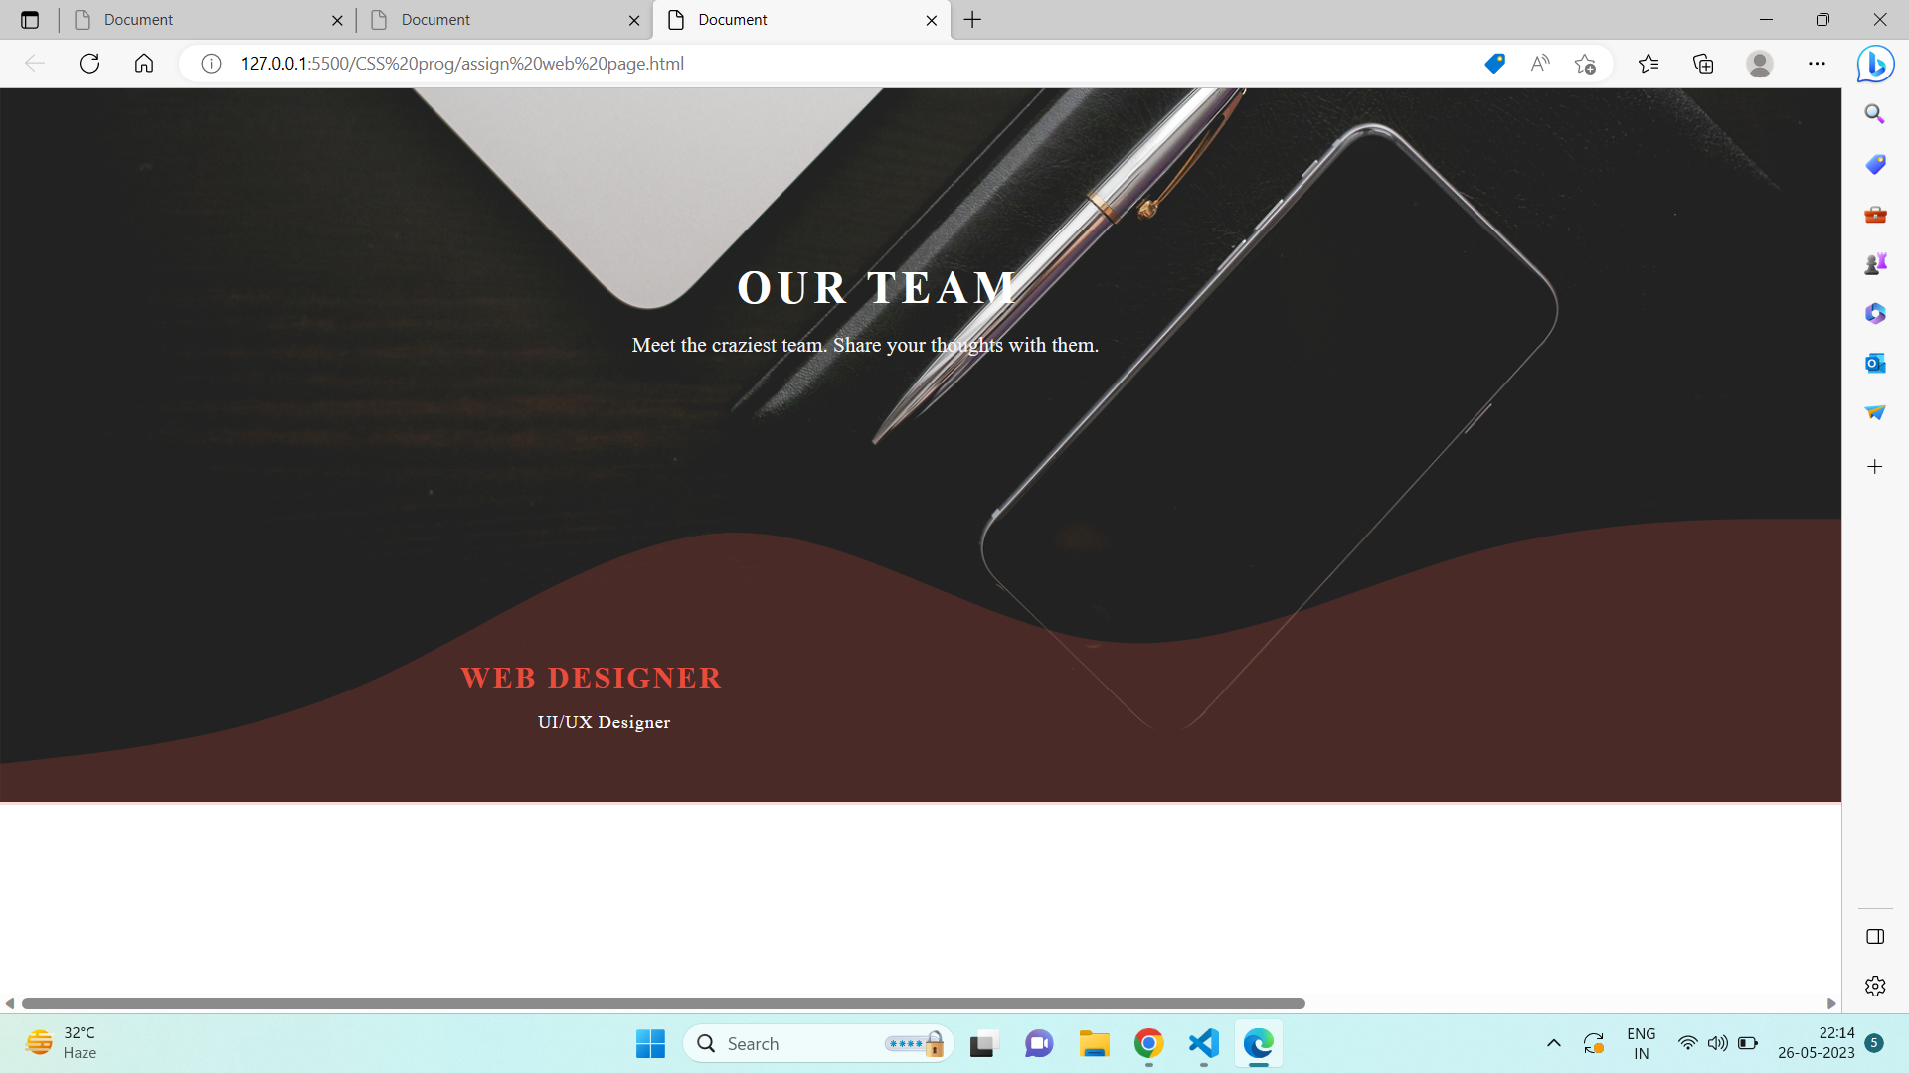

---------------------------------------------------------------------------------------------------

**Que. 22) Create Layouts**

**Ans:Code**

<!DOCTYPE html>

<html lang="en">

<head>

<meta charset="UTF-8">

<meta http-equiv="X-UA-Compatible" content="IE=edge">

<meta name="viewport" content="width=device-width, initial-scale=1.0">

<title>Document</title>

<style>

* {

margin: 0;

padding: 0;

box-sizing: border-box;

}

/* Card style */

.card {

display: inline-block;

height: 300px;

position: relative;

top: 20px;

left: 20px;

width: 20%;

margin-inline: 10px;

border: 2px solid gray;

}

.one

{

position: relative;

height: 130px;

padding: 40px;

background-color: rgba(12, 11, 11, 0.859);

color: white;

text-align: center;

}

p {

position: relative;

top: 20px;

padding: 15px;

text-align: justify;

}

button {

position: relative;

top: 30px;

left: 15px;

padding: 2px;

margin: 2px;

margin-inline: -2px;`

}

/* 4th to 6th card style */

.two {

position: relative;

top: -8px;

left: 75%;

}

.main-1 {

position: relative;

top: 20px;

}

</style>

</head>

<body>

<!-- 1st to 3rd card -->

<div class="main">

<!-- Card 1 -->

<div class="card">

<div class="one">

<h1>Thumbnail</h1>

</div>

<div>

<p>Lorem ipsum dolor sit amet consectetur, adipisicing elit. Vel nulla autem commodi eos assumenda </p>

<button>View</button>

<button>Edit</button>

<p class="two">lorem</p>

</div>

</div>

<!-- Card 2 -->

<div class="card">

<div class="one">

<h1>Thumbnail</h1>

</div>

<div>

<p>Lorem ipsum dolor sit amet consectetur, adipisicing elit. Vel nulla autem commodi eos assumenda </p>

<button>View</button>

<button>Edit</button>

<p class="two">lorem</p>

</div>

</div>

<!-- Card 3 -->

<div class="card">

<div class="one">

<h1>Thumbnail</h1>

</div>

<div>

<p>Lorem ipsum dolor sit amet consectetur, adipisicing elit. Vel nulla autem commodi eos assumenda </p>

<button>View</button>

<button>Edit</button>

<p class="two">lorem</p>

</div>

</div>

</div>

<!-- 4th to 6th card -->

<div class="main-1">

<!-- Card 4 -->

<div class="card">

<div class="one">

<h1>Thumbnail</h1>

</div>

<div>

<p>Lorem ipsum dolor sit amet consectetur, adipisicing elit. Vel nulla autem commodi eos assumenda </p>

<button>View</button>

<button>Edit</button>

<p class="two">lorem</p>

</div>

</div>

<!-- Card 5 -->

<div class="card">

<div class="one">

<h1>Thumbnail</h1>

</div>

<div>

<p>Lorem ipsum dolor sit amet consectetur, adipisicing elit. Vel nulla autem commodi eos assumenda </p>

<button>View</button>

<button>Edit</button>

<p class="two">lorem</p>

</div>

</div>

<!-- Card 6 -->

<div class="card">

<div class="one">

<h1>Thumbnail</h1>

</div>

<div>

<p>Lorem ipsum dolor sit amet consectetur, adipisicing elit. Vel nulla autem commodi eos assumenda </p>

<button>View</button>

<button>Edit</button>

<p class="two">lorem</p>

</div>

</div>

</div>

</body>

</html>

<**Output:**



